Project Planning Phase

Project Planning Template (Product Backlog, Sprint **Planning,** Stories, Story points)

|  |  |
| --- | --- |
| Date | 28 October 2022 |
| Team ID | PNT2022TMID15297 |
| Project Name | Classification Of Arrhythmia By Using  Deep Learning With 2-D ECG Spectral Image Representation |
| Maximum Marks | 8 Marks |

Product Backlog, Sprint Schedule, and Estimation (4 Marks)

Use the below template to create product backlog and sprint schedule

|  |  |  |  |  |  |  |
| --- | --- | --- | --- | --- | --- | --- |
| **Sprint** | **Functional Requirement (Epic)** | **User** Story **Number** | **User Story / Task** | **Story Points** | **Priority** | **Team Members** |
| Sprint-1 | Download The  Dataset | USN-1 | We will download the Dataset contains  Six classes | 2 | Low | Hariharan |
| Sprint-1 | Import The Image  Data Generator Library | USN-2 | We will import Image Data Generator | 2 | Low | Hani rahim |
| Sprint-1 | Configure Image  Data Generator class | USN-3 | We will configure the  Image Data Generator class | 6 | Medium | SaiSaran K |
| Sprint-1 | Apply the Image | USN-4 | We will apply Image Data Generator | 10 | High | Hariharan,  Saisaran K |
| Data Generator | to |
| functionality to Train Dataset | train dataset |

|  |  |  |  |  |  |  |
| --- | --- | --- | --- | --- | --- | --- |
| **Sprint** | **Functional Requirement (Epic)** | User **Story Number** | **User Story / Task** | **Story Points** | **Priority** | **Team Members** |
| Sprint-2 | Import Libraries | USN-5 | We will import required Libraries | 1 | Low | Naren |
| Sprint-2 | Initialize the Model | USN-6 | Initializing the Image recognition model | 1 | Medium | Naren |
| Sprint-2 | Adding CNN layer | USN-7 | We will add Convolutional Neural  Network (CNN) used for image/object recognition and classification | 4 | High | Naren |

|  |  |  |  |  |  |  |
| --- | --- | --- | --- | --- | --- | --- |
| Sprint-2 | Adding Dense Layer | USN-8 | We will add Dense Layer in which each  neuron receives input from all the neurons of previous layer | 4 | High | Hani Rahim |
| Sprint-2 | Configure The  Learning Process | USN-9 | We will configure The Learning process  which is a method, mathematical logic or algorithm that improves the network's performance and/or training time. | 2 | Medium | Hariahran |
| Sprint-2 | Train the Model | USN-10 | We will train our model with our  image dataset. Fit generator functions used to train a deep learning neural  network | 4 | High | Saisaran |
| Sprint-2 | Save the Model | USN-11 | We will save The model with .h5  extension | 2 | Medium | Saisaran |
| Sprint-2 | Test the model | USN-12 | We will Test the model through Loaded  necessary libraries, the saved model | 2 | Medium | Hariharan |

|  |  |  |  |  |  |  |
| --- | --- | --- | --- | --- | --- | --- |
| **Sprint** | **Functional**  **Requirement (Epic)** | **User Story** Number | **User Story / Task** | **Story Points** | **Priority** | **Team Members** |
| Sprint-3 | Create Html files | USN-13 | We use HTML to create the front end  part of the web page. | 8 | High | Naren, Saisaran |
| Sprint-3 | Build Python code | USN-14 | We build the flask file ‘app.py’ which is  a web framework written in python for server-side scripting. | 8 | High | Hani Rahim |
| Sprint-3 | Run the App | USN-15 | We can run the App | 4 | Medium | Hariharan |
| Sprint-4 | Register IBM Cloud | USN-16 | We can register IBM Cloud | 6 | Medium | Hariharan |
| Sprint-4 | Train the model on  IBM | USN-17 | We can Train Out model on IBM | 14 | High | Hani Rahim, Saisaran |

**Project Tracker, Velocity & Burndown Chart: (4 Marks)**

|  |  |  |  |  |  |  |
| --- | --- | --- | --- | --- | --- | --- |
| Sprint | Total Story Points | Duration | Sprint Start Date | Sprint End Date (Planned) | Story Points Completed (as on Planned End Date) | Sprint ReleaseDate (Actual) |
| Sprint-1 | 20 | 6 Days | 24Oct2022 | 29 Oct2022 | 20 | 29 Oct 2022 |
| Sprint-2 | 20 | 6 Days | 31Oct2022 | 05Nov 2022 | 20 | 05 Nov 2022 |
| Sprint-3 | 20 | 6 Days | 07Nov 2022 | 12 Nov 2022 | 20 | 12 Nov 2022 |
| Sprint-4 | 20 | 6 Days | 14Nov 2022 | 19 Nov 2022 | 20 | 19 Nov 2022 |

**Velocity:**

To calculate the team’s average velocity (AV) per iteration unit

Where

*Av ——*

**Average Velocity** - Story points per day



**Sprint duration** - Number of days (Duration) for Sprints

**Velocity** - Points per Sprint

A=20/6= 3.3

Average velocity is 3.3 points per Sprint

**Burndown Chart:**

A burndown chart is a graphical representation of work left to do versus time. It is often used in agile software development methodologies such as Scrum. However, burn down charts can be applied to any project containing measurable progress over time.

**Burndown Chart:**

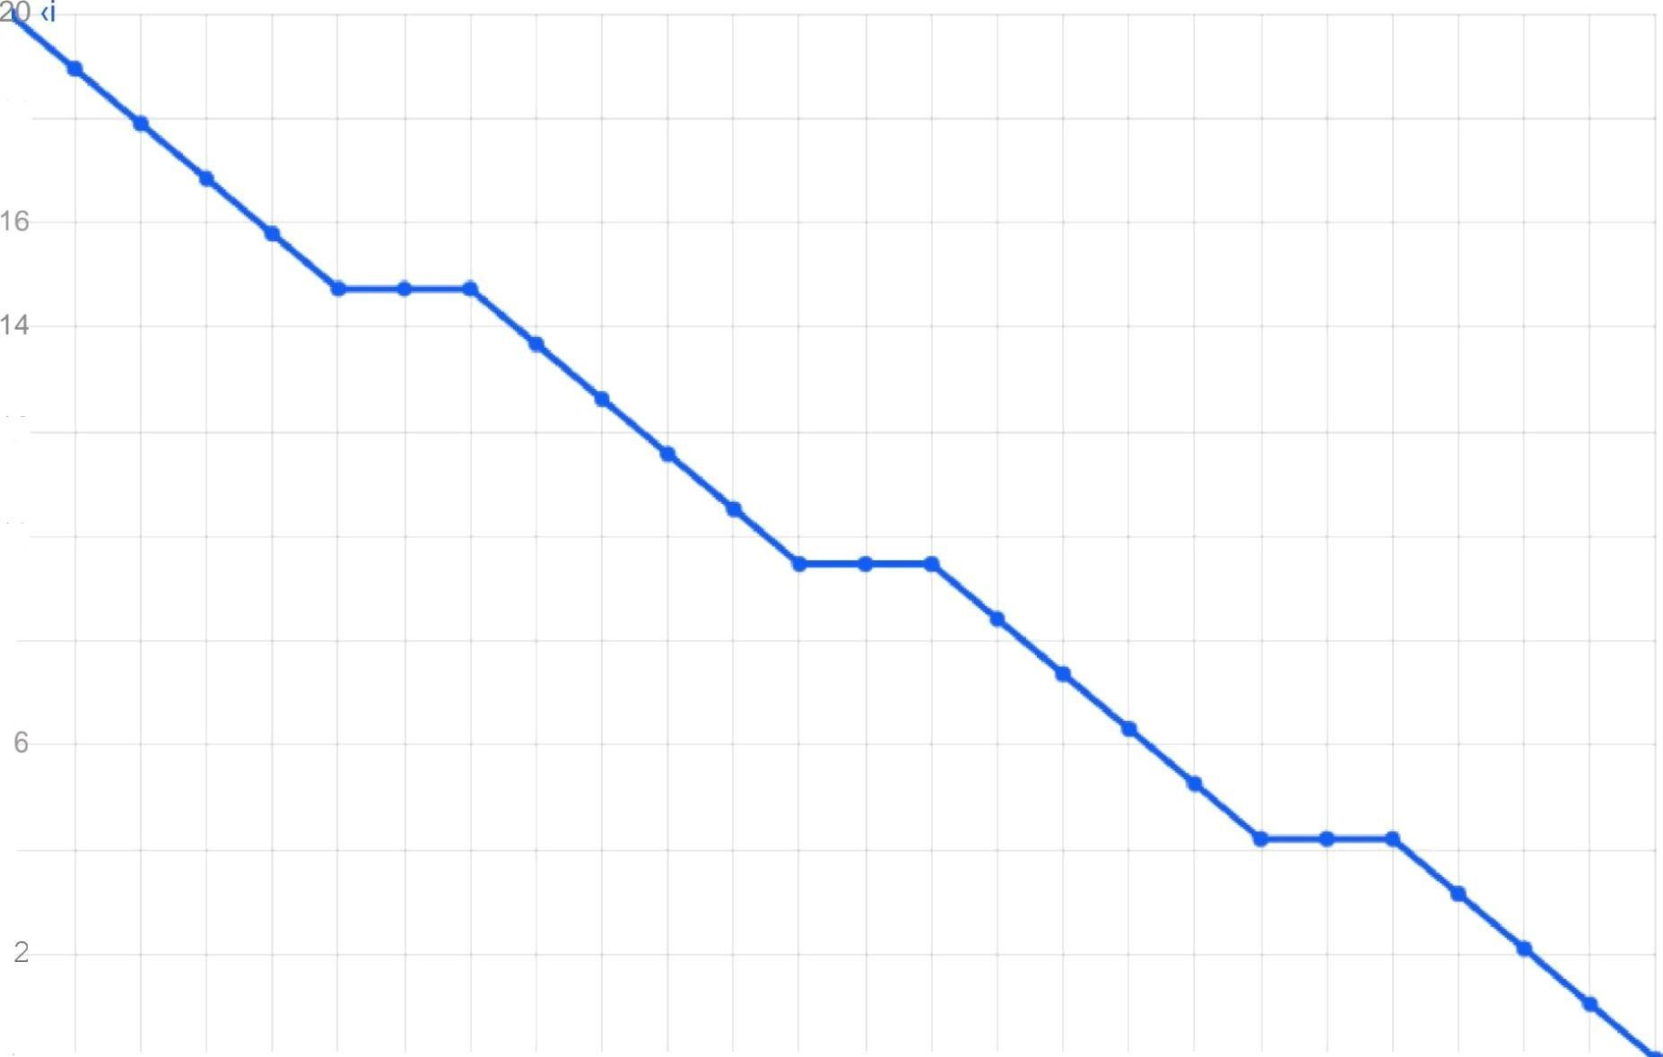

48

12

10